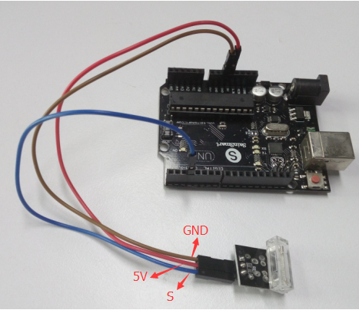

int Led = 13 ;// define LED Interface

int Shock = 3; // define the percussion Sensor Interface

int val ;// define numeric variables val

void setup ()

{

pinMode (Led, OUTPUT) ;// define LED as output interface

pinMode (Shock, INPUT) ;// define knock sensor output interface

}

void loop ()

{

val = digitalRead (Shock) ;// read digital interface is assigned a value of 3 val

if (val == HIGH) // When the percussion when the sensor detects a signal, LED flashes

{

digitalWrite (Led, LOW);

}

else

{

digitalWrite (Led, HIGH);

}

}